
Symbiosis Institute of Technology, Pune
CSE- Academic Year 2026-27
Java Programming – Lab Batch 2025-29
Lab Assignment No.: 17
Name of Student | Akshit Gawade
PRN No. | 25070122029
Batch | 2025-2029
Class | A1
Academic Year & Semester | Second Year  Semester III
Date of Submission
Title of Assignment: | Write a Java program to demonstrate the use of Swing and Applets
Problem Statement  &  Learning  Objective | Problem Statement  Write a Java program to demonstrate the use of Swing and Applets  Learning Objectives  To develop graphical user interfaces using Swing components and Applets.
Theory | Swing is Java's GUI toolkit that provides lightweight components such as buttons, labels, text fields, and menus. Applets were small Java programs embedded in web pages for interactive applications. Although Applets are obsolete, Swing remains an important framework for desktop application  development. Swing supports platform-independent graphical interfaces.
Program Code | Main1: (swing)  import javax.swing.*;  public class Main1 {  public static void main (String[] args) {  JFrame frame = new JFrame("Swing Demo");  JLabel label = new JLabel("Welcome to Java swing!", JLabel.CENTER);  frame.add(label);  frame.setSize(350, 200);  frame.setDefaultCloseOperation(JFrame.EXIT_ON_CLOSE);  frame.setVisible(true);  }  }  Main2: (applet)  import java.applet.*;  import java.awt.*;  public class Main2 extends Applet {  public void paint (Graphics g) {  g.drawString("Welcome to Java Applet", 50, 50);  }  }  ==============================================================  AppletDemo.html:  <!DOCTYPE html>  <html>  <head>  <title>Applet Demo</title>  </head>  <body>  <applet code="Main2.class" width="300" height="150">  Your browser does not support Java Applets.  </applet>  </body>  </html>
Output Screenshots | Main1:  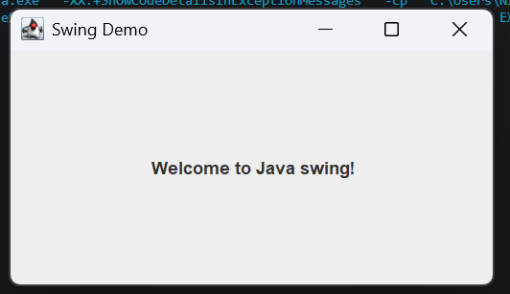  Main2:  No output, Applet is depreciated.  Demo:  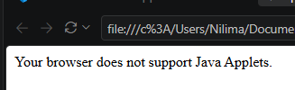
Exercise Qns  and Code | - Create a simple Student Registration Form GUI using Swing.  import javax.swing.*;  public class Exp1 {  public static void main (String[] args) {  JFrame frame = new JFrame("Student Registration Form");  JLabel nameLabel = new JLabel("Name:");  JLabel rollLabel = new JLabel("Roll No:");  JLabel courseLabel = new JLabel("Course:");  JTextField nameField = new JTextField();  JTextField rollField = new JTextField();  JTextField courseField = new JTextField();  JButton submitButton = new JButton("Submit");  nameLabel.setBounds(50, 50, 100, 30);  nameField.setBounds(150, 50, 200, 30);  rollLabel.setBounds(50, 100, 100, 30);  rollField.setBounds(150, 100, 200, 30);  courseLabel.setBounds(50, 150, 100, 30);  courseField.setBounds(150, 150, 200, 30);  submitButton.setBounds(150, 210, 100, 30);  frame.add(nameLabel);  frame.add(nameField);  frame.add(rollLabel);  frame.add(rollField);  frame.add(courseLabel);  frame.add(courseField);  frame.add(submitButton);  frame.setSize(420, 320);  frame.setLayout(null);  frame.setVisible(true);  submitButton.addActionListener(e -> {  JOptionPane.showMessageDialog(  frame,  "Registration Successful!\nName: " + nameField.getText()  + "\nRoll No: " + rollField.getText()  + "\nCourse: " + courseField.getText()  );  });  }  }  2. Create a simple Employee Registration Form using Java Swing GUI that takes employee details such as Employee ID, Name, Department, and Salary. Display the entered information in a dialog box  import javax.swing.*;  public class Exp2 {  public static void main (String[] args) {  JFrame frame = new JFrame("Employee Registration Form");  JLabel idLabel = new JLabel("Employee ID:");  JLabel nameLabel = new JLabel("Name:");  JLabel deptLabel = new JLabel("Department:");  JLabel salaryLabel = new JLabel("Salary:");  JTextField idField = new JTextField();  JTextField nameField = new JTextField();  JTextField deptField = new JTextField();  JTextField salaryField = new JTextField();  JButton submitButton = new JButton("Submit");  idLabel.setBounds(40, 40, 100, 30);  idField.setBounds(150, 40, 200, 30);  nameLabel.setBounds(40, 90, 100, 30);  nameField.setBounds(150, 90, 200, 30);  deptLabel.setBounds(40, 140, 100, 30);  deptField.setBounds(150, 140, 200, 30);  salaryLabel.setBounds(40, 190, 100, 30);  salaryField.setBounds(150, 190, 200, 30);  submitButton.setBounds(150, 240, 100, 30);  frame.add(idLabel);  frame.add(idField);  frame.add(nameLabel);  frame.add(nameField);  frame.add(deptLabel);  frame.add(deptField);  frame.add(salaryLabel);  frame.add(salaryField);  frame.add(submitButton);  frame.setSize(420, 350);  frame.setLayout(null);  frame.setVisible(true);  submitButton.addActionListener(e -> {  JOptionPane.showMessageDialog(  frame,  "Employee Details\n"  + "Employee ID: " + idField.getText()  + "\nName: " + nameField.getText()  + "\nDepartment: " + deptField.getText()  + "\nSalary: " + salaryField.getText()  );  });  }  }
Output Screenshots | Exp1:  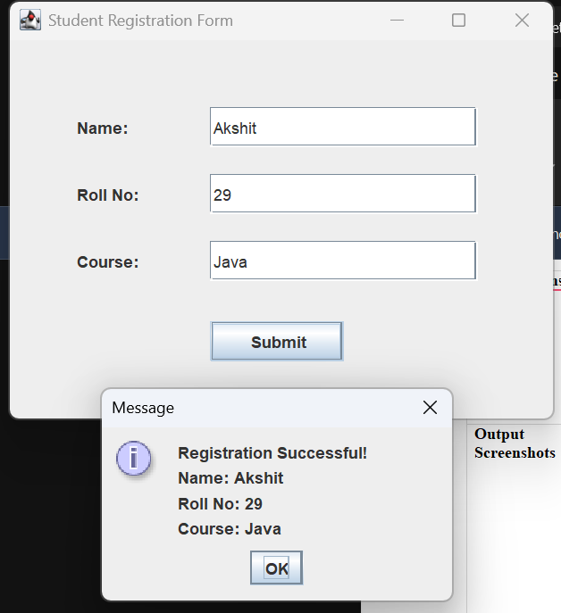  Exp2:  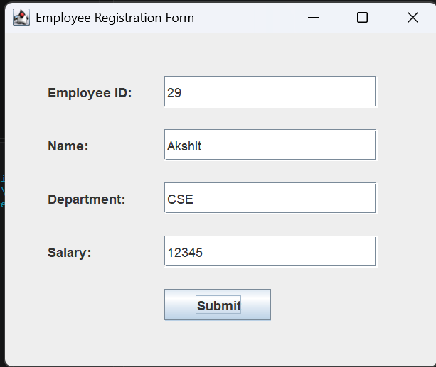  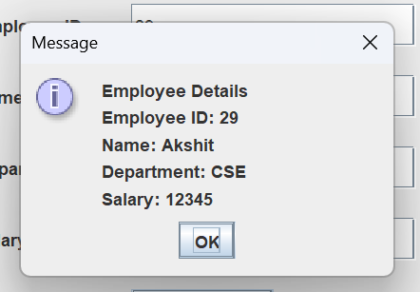
Conclusion | This experiment focuses on constructing Graphical User Interfaces using Java Swing components. By arranging containers and widgets like JFrame and JTextField, it details component layout management and cross-platform desktop UI development while contrasting modern Swing applications with legacy browser-based applets.

